IBM Cloud Essentials:  [https://www.youracclaim.com/badges/975cff4e-c867-4762-91f3-b4b9f27e5181](https://apc01.safelinks.protection.outlook.com/?url=https%3A%2F%2Fwww.youracclaim.com%2Fbadges%2F975cff4e-c867-4762-91f3-b4b9f27e5181&data=02%7C01%7CSenthilS.S%40hcl.com%7Ca1ee6d791a694b357f5b08d7cbad0f52%7C189de737c93a4f5a8b686f4ca9941912%7C0%7C0%7C637201816468751161&sdata=Owd2QU4QAGf7z4ckXiEZEBEfu2lTAHx0un7F7uEeKfk%3D&reserved=0)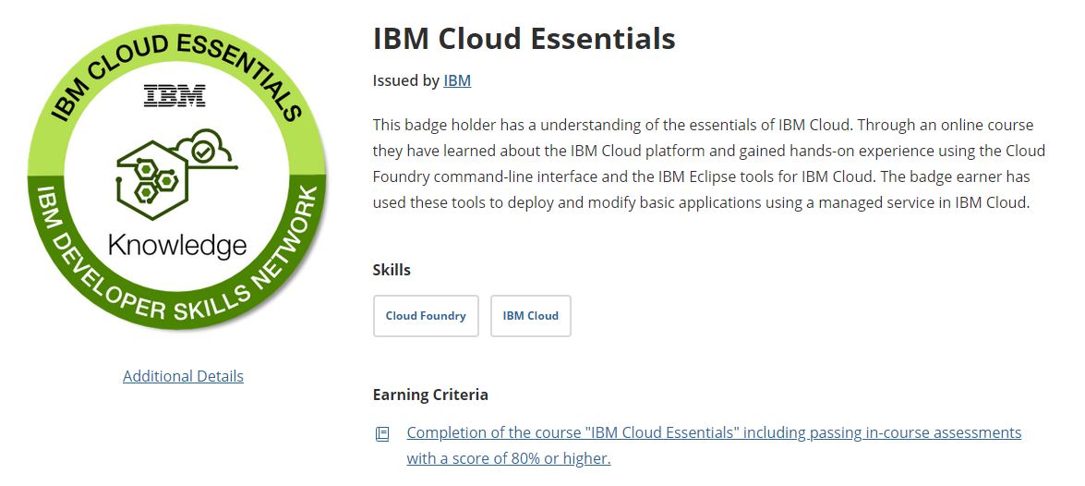

Docker Essentials: [https://www.youracclaim.com/badges/c484061d-9883-4110-ba33-ae7108350138](https://apc01.safelinks.protection.outlook.com/?url=https%3A%2F%2Fwww.youracclaim.com%2Fbadges%2Fc484061d-9883-4110-ba33-ae7108350138&data=02%7C01%7CSenthilS.S%40hcl.com%7Ca1ee6d791a694b357f5b08d7cbad0f52%7C189de737c93a4f5a8b686f4ca9941912%7C0%7C0%7C637201816468761156&sdata=y7vM07vSKI%2F8IBjhqr%2Fk5AmsdzjD8lr2utgzQiEoFUY%3D&reserved=0)

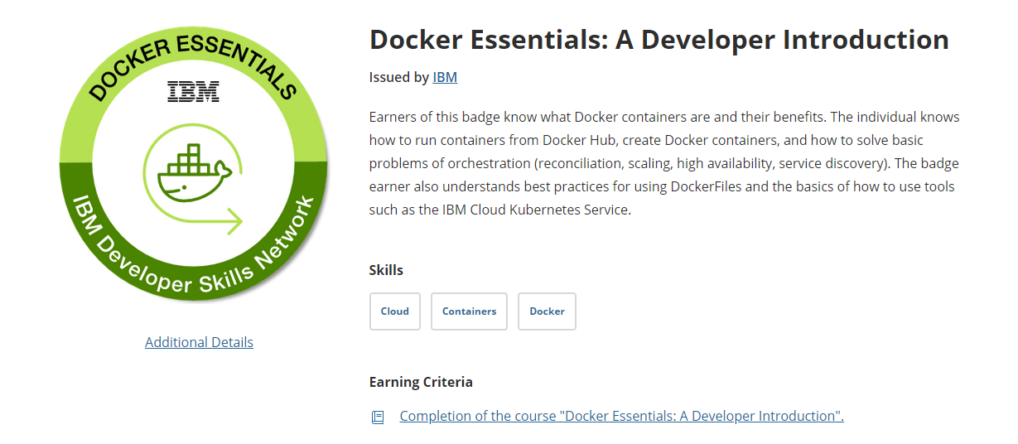

IBM Cloud and Dockers essentials badge i can learn additionally. Time duration is before June 2020.

* Do have any front end developer related badges if anything available shares those links?

**Web Developer Roadmap (**https://github.com/kamranahmedse/developer-roadmap)

Roadmap has **Frontend Developer**, Backend Developer and DevOps

Mainly I focused **Front End Development**

**How Internet does is working**

* DNS, Domain Name, Hosting and how it works –
* I understand it is human-readable name like [www.hcl.com](http://www.hcl.com) – which we type in web browser URL field.
* We have most TLD(Top Level Domain) .com, .net, .gov, .org and .info
* I have hands on experience in Bluehost server buy domain and hosting website in server, it is located in US.

**DOM Manipulations**

* HTML basis, sematic, forms, validations, accessibility and SEO basis –
* In this topic I understand the HTML basis syntax how to implement the syntax throughout the web pages properly need to close the tags.

**Q: Do you have any from validation in our Ads?**

**Q: Are we using Accessibility test?**

**Q: How we are generating SEO Key words in Ads?**

* CSS Layout, RWD, Media queries (Flex layout, Box model, position, selectors)
* I understand from this topic the how the web pages make appearance and behavior makes good.
* RWD(Responsive web design) make the page compactible to multiple device
* Grid layout is dividing the pages like size, position and layer
* Pre-processors is used reduce the multiple time used class name.

**Q: In our Ads we are using any Grid Layout?**

**Q: Are we using any CSS framework like Bootstrap3/4, Pure CSS and Angular Material UI?**

**Q: IBM also having CSS framework like Carbon CSS framework are we going to use this?**

* JavaScript syntax and basic constructs, DOM manipulation and ES6.
* JavaScript understanding DOM Event Life Cycle like capture phase, target phase and bubbling phase how the life cycle is working browser
* Skeleton of DOM tree structure and How each event is working user action performance
* New feature are added in ES6, i understand how the code we can reduce using arrow function

**Q: What JavaScript frameworks we are using to build the Ads?**

**Q: Why we are going for that particularly framework? Can you tell me the advantage?**

**Package Manger**

* Node package manager I have hands on experience, it is useful for server side dependencies.
* Npm install downloads dependencies defined in a package.json file and generated the node_modules.

**Adlab:** [https://adlab.weather.com/library/](https://apc01.safelinks.protection.outlook.com/?url=https%3A%2F%2Fadlab.weather.com%2Flibrary%2F&data=02%7C01%7CSenthilS.S%40hcl.com%7Ca1ee6d791a694b357f5b08d7cbad0f52%7C189de737c93a4f5a8b686f4ca9941912%7C0%7C0%7C637201816468781142&sdata=ahdoSmIv%2Fwhd9HnWpfuXthB8Z6J0%2Fq7WGbrlB2vwARs%3D&reserved=0)

**Adlab three type of ads like**

* Dynamic Display –for my understanding user search some products in browsed on the website or video/ images on websites it will show like that in dynamically to display.
* Integrated Marquee – it’s also brand imagery, adaptive weather information.
* Watson Ads – for my understanding Watson ads are advertising products, giving real-time weather targeting solution and using AI for consumer more relevant information.

**Creative Lab design and builds**

* For my understanding integrated marquee ads is multiple variations views like mobile app, mobile web and desktop web, its width and height is 300X480, 300X250 and 970X250.
* For ad building Each and every stage has time duration is there. Scratch to develop the screen, develop and test it.
* Then it would be launched

**Q: How to communicate to designers, how designer team shares the design layout to me?**

**Q: How many variation designer will provide for mobile screens?**

**For my global understanding of Ads building:**

* We need to follow the spec, design will provide by designer in location IBM box folder
* Ads have four compartments like Weather adaptation, Regular or Large vision, Background Area and Interactive Area.
* Weather adaptation has eight different UI like Clear, Cloudy, Rainy and Wintry – Day and Night.
* Regular and Large version device layout like (iPhone 6/7/8) and iPhone XS.
* Background area 1242X600 regular and 1242X720 Large
* Interactive user like CTA Scene, Video, Image, Swipe and Button.
* Max file weight for initial load is 200KB to 2.5MB
* Design page has .psd file format

**Q: What are tool we are using?**

**Q: Are we following same template like Watson Ads?**

**Q: Ads App four compartments like Weather Adaption, Regular or Large Version, Background and Interactive Area it is standard?**

Weird js (<https://www.youtube.com/watch?v=Bv_5Zv5c-Ts>)

Its Three hours thirty two minutes video it is fully JavaScript orientated

* For my understand setup the **chrome browser** and code demonstration they are using code editor tool like **bracket.io**
* JavaScript **syntax parsers**, how the code is execution browser engine.
* **Global execution context and Execution context**, for my understanding we have two function like a() and b(). In Function b() we can call the method a() inside. The code is process to execute In way of Global code is executed and followed by execute a() and b().
* Name and value is data store in stack
* **Object** is unique entity which contains **property and method** for my real time experience hospital management have different kind of equipment like Microscope, Microscope is property and method are color, lens, type and power are action like drive.
* **Undefined** for example var a is defined but value is not yet defined so it is called undefined.
* Error throughout uncaught reference a is not defined
* **Undeclared** a variable that has been declared without ‘var’ keyword
* JavaScript has run to execute line by line
* Thread concept, **Single thread and Synchronous execution**. Single thread has one command at a time but synchronous is order one by one at a time.
* JavaScript **Types are primitive and non-primitives**, here I understand about how to types declare in program (Types: String, Numbers, Null, Boolean, Object, undefined)
* **Operator** like Addition, Subtraction, Multiplication, Division, Modulus, Increment and Decrement. This operator is perform arithmetic operation like addition two values etc..
* **Function** is defined with function keyword. We can write function has different ways like function invocation, Function closures, Function anonymous.
* **Function self-executing** is automatically call once the method is finished and without function name is called **anonymous function** where we will use this for **event listener** time.
* **ES6** new features are let, const, arrow function, default parameter and Exponentiation.
* Let is block scope used in if, switch and while conditions. Const is not modified but we can modified using of push method. Arrow function is reduced the code.
* **Don’t have any question in this topic.**

**MRAID** - Stands for Mobile Rich Media Ad Interface Definition.

**What is MRAID?**

It is indirect communication between an ad and mobile app.

**Scope of MRAID**

* Retrieving the ad from Ad Server, Ad Network, or local resources. Ads are stored in Ad server and local resource to publish the corresponding destination.
* Reporting, it will show the weather report for daily or weekly basis to the TWC
* IDE integrations, for my understanding it will be software application code editor, build automation tool and a debugger.
* Security / Privacy
* Internationalization
* Error reporting
* Logging
* Billing and payments
* Ad dimensions and ad behavior, MRAID is have compactible for all mobile device.
* Downloading of assets to the local file system for caching or off-line use

**Q: What Ad server we are using and how we are controlling the networking traffic?**

**Q: What kind of reporting we are generating in app?**

**Q: What are the Security and Privacy using in Ads?**

**Q: Need more clarification Internationalization, Error reporting, Logging and billing/payments.**

**How MRAID works**

**For my understanding,**

* MRAID protocol between two systems, each system must be equipped to follow the call and response expectations.
* Vendor give the requirement based on that we develop the Mobile ad component.
* Ad Designer or Ad Developer use MRAID to implement interactive features.
* Ad Technologist uses scripts to standardize the functionality to MRAID specifications.
* Vendor may give some recommendations for designs that simplify the process
* In that component we have one container and simple JavaScript tag initiates.
* Inside the Container ad can be executed.

**Q: MRAID Life cycle work flow?**

**Version**

MRAID 3.0 support both improved tracking and better performance for higher quality ads.